Budoucí čas be + going to
- používáme k popisu (téměř) jisté budoucnosti


Oznamovací tvar
I am going to fall – Já spadnu
You are going to fall – Ty spadneš
He is going to fall – On spadne
She is going to fall – Ona spadne
It is going to fall – To spadne
We are going to fall – My spadneme
You are going to fall – Vy spadnete
They are going to fall – Oni spadnou

Ona tam dnes bude………………………..……………………………………………(be)
Půjdu večer do kina……..…………..……...................................................................(go)
Sejdeme se v devět.......................................................................................................(meet)

Zápor
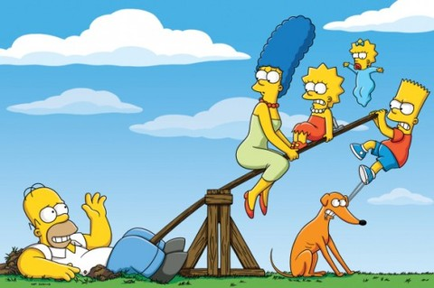
I am not going to fall – Já nespadnu
You aren´t going to fall – Ty nespadneš
He isn´t going to fall – On nespadne
She isn´t going to fall – Ona nespadne
It isn´t going to fall – To nespadne
We aren´t going to fall – My nespadneme
You aren´t going to fall – Vy nespadnete
They aren´t going to fall – Oni nespadnou

Ona tam dnes nebude…………………………………………………………….………
Nepůjdu večer do kina……..…………..……................................................................
Nesejdeme se v devět......................................................................................................

Otázka

Am I going to fall? – Spadnu?
Are you going to fall? – Spadneš?
Is he going to fall? – Spadne (on)?
Is she going to fall? – Spadne (ona)?
Is it going to fall? – Spadne to?
Are we going to fall? – Spadneme?
Are you going to fall? – Spadnete?
Are they going to fall? – Spadnou?

Krátká odpověď

Bude tam dnes (ona)?………………………..…………………………Yes………………/ No…….………
Půjdu večer do kina?……..…………..……............................................ Yes………………/ No…….…….
Sejdeme se v devět?................................................................................ Yes………………/ No…….………
Kde se sejdeme?...........................................................................................

