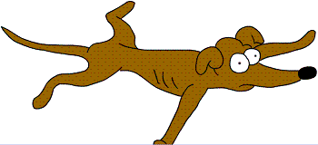
Co to je? ..........................................What is it?
Tohle je můj pes. .............................This is my dog.
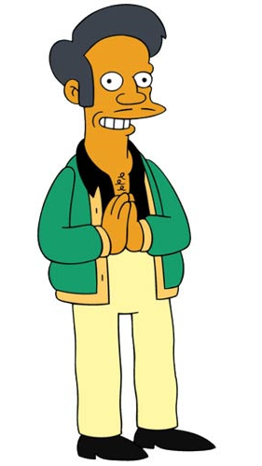
Kdo to je? .........................................Who is it?
To je Apu. .........................................It’s Apu.
To je Lisa. .........................................It’s Lisa.
To jsem já. ........................................It’s me.
Odkud je? (on) .................................Where is he from?
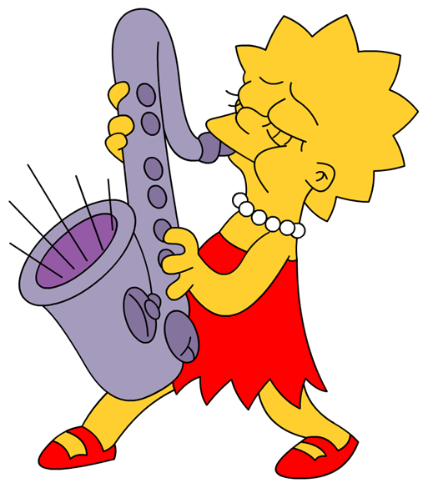
Odkud je? (ona) ...............................Where is she from?
Odkud jsi? ........................................Where are you from?
On je z Indie. ....................................He is from India.
Ona je z USA. ..................................She is from USA.
Já jsem z České republiky. ...............I am from Czech Republic.
Kde žije? (on) ..................................Where does he live?
Kde žije? (ona) ................................Where does she live?
Kde žiješ? ........................................Where do you live?
On žije v Bombayi............................He lives in Bombay.
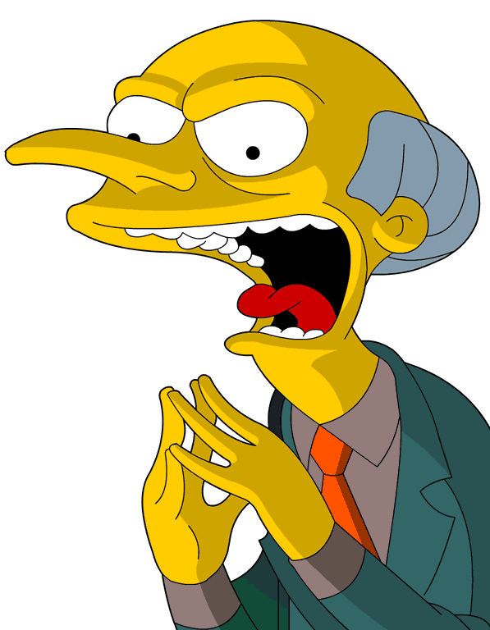
Ona žije ve Springfieldu ..................She lives in Springfield.
Já žiji v Rokycanech. .......................I live in Rokycany.
Jak se jmenuje? (on) ........................What is his name?
Jak se jmenuje? (ona) ......................What is her name?
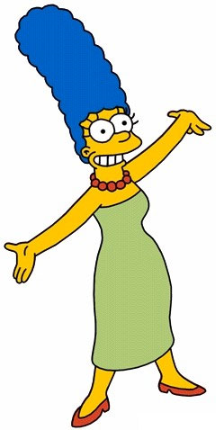
Jak se jmenuješ? ..............................What is your name?
On se jmenuje pan Burns. .............. His name is Mr. Burns.
Ona se jmenuje Marge Simpson. ... Her name is Marge Simpson.
Já se jmenuji Martin. ......................My name is Martin.
Kolik je mu let? ..............................How old is he?
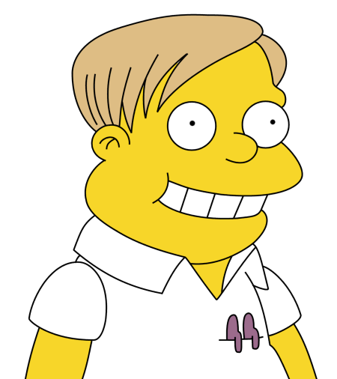
Kolik je jí let? .................................How old is she?
Kolik je ti let? .................................How old are you?
Je mu 81...........................................He is 81.
Je jí 38. ..........................................She is 38.
Je mi 12 ...........................................I am 12.

